Topic 6.10: Unique Permutations of an Array
Question
Given a collection of numbers nums, that might contain duplicates, return all possible unique permutations in any order.
Aim
To generate all unique permutations of an array that may contain duplicates using backtracking.
Algorithm
- Sort the input array to group duplicates together.
- Use backtracking with a visited array to track which elements have been used.
- At each recursive call:
  - If the path length equals the array length, store the path as a valid permutation.
  - Skip over duplicate elements if they have been used in the same recursion level.
- Continue until all unique permutations are generated.
Output
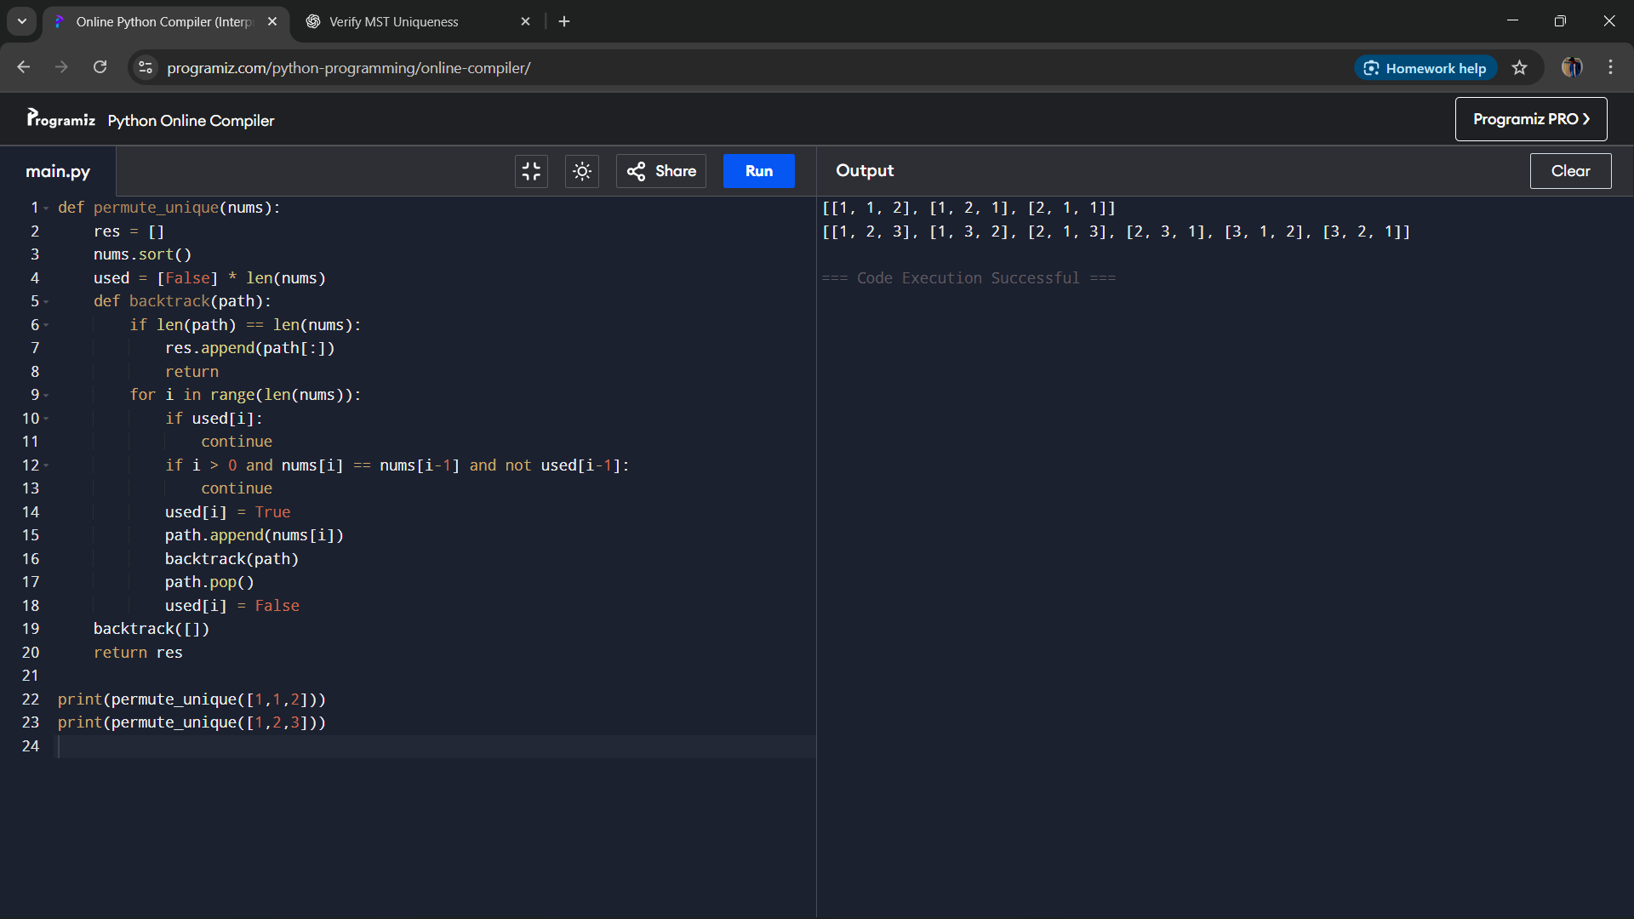
Result
The program generates all unique permutations of an array that may contain duplicates.
Performance Analysis
- Time Complexity: O(n × n!), since there are up to n! permutations and each takes O(n) to build.
- Space Complexity: O(n) for recursion depth and O(n!) for storing results.

